**Reissue File Vault Recovery Key**

1. Open the **system preferences** and then **Profiles**.
2. **Default Plan – Jamf Protect Configuration** must be **verified**.
3. Open the **Self Services** and then click on all you will be able to see **Reissue File Vault Recovery Key.**

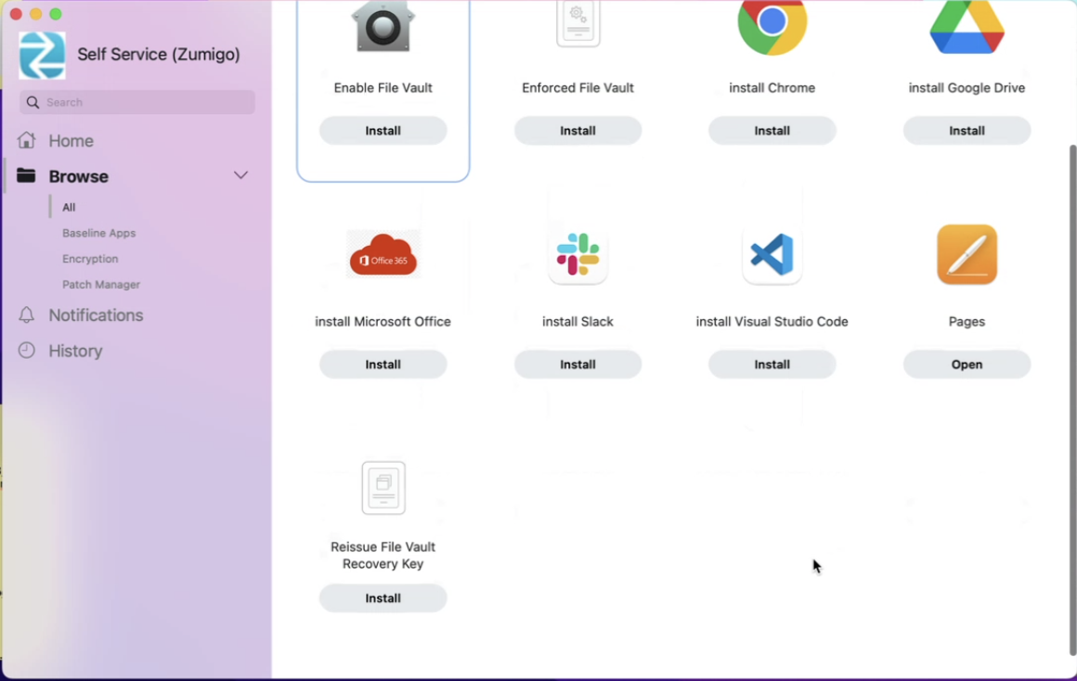

1. Click on **Install**. This will ask for **Encryption key Escrow** then click on Next.

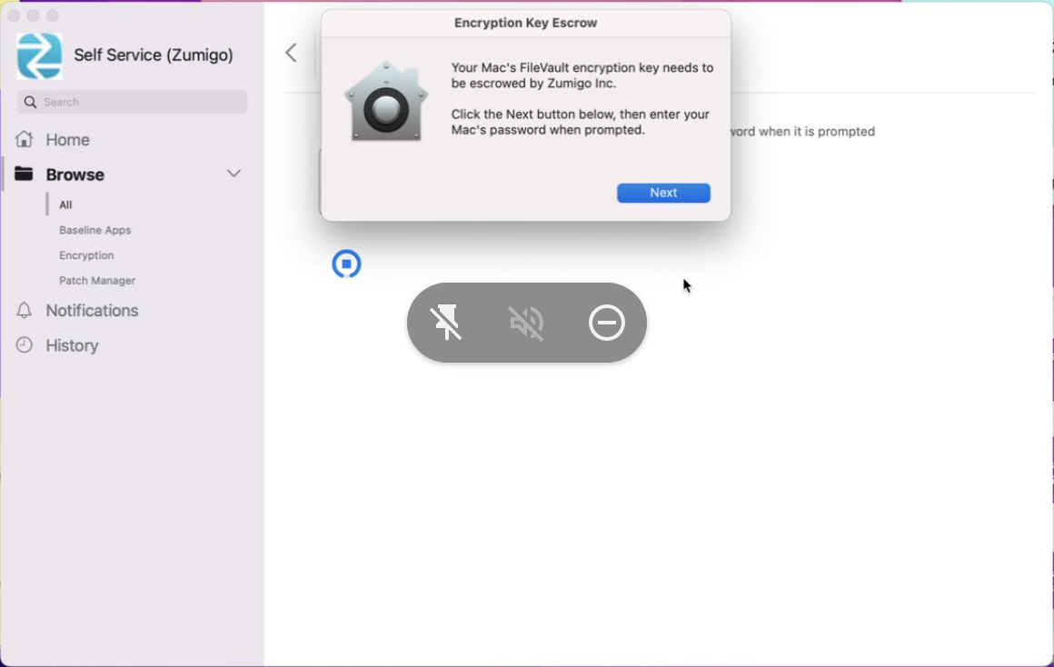

1. Then it will ask for the **Password**. Please Enter the laptop’s Password.

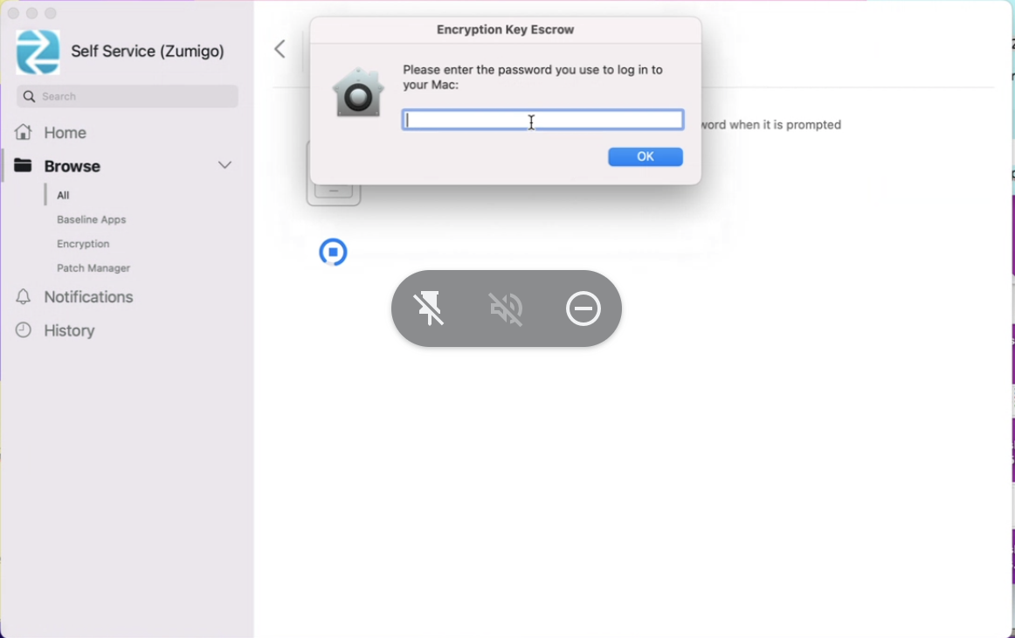

1. Please wait for the process. Once **Install** it will show like this (asking for Reinstall)

